Master’s Thesis
Liebherr Draglines in Mining Operations in India – Technical Feasibility and Economic Evaluation

Subtitle of the paper (optional)

Ajay Bihari Sahu

Declaration of Authorship

„I declare in lieu of oath that this thesis is entirely my own work except where otherwise indicated. The presence of quoted or paraphrased material has been clearly signaled and all sources have been referred. The thesis has not been submitted for a degree at any other institution and has not been published yet.”

Preface, Dedication, Acknowledgement

Abstract

Zusammenfassung

Table of Contents

Declaration of Authorship II
Preface, Dedication, Acknowledgement III
Abstract IV
Zusammenfassung V
Table of Contents VI
1 Introduction 1
1.1 Indian surface mining and overburden removal 1
1.2 Problem statement and motivation 2
1.3 Objectives of the Study 3
1.4 Scope and Limitations 3
1.5 Methodology and Outlines 4
1.6 Thesis Structure 5
2 Background and Literature Review 6
2.1 Economic and Regulatory Context 7
2.2 Geological and Mineral Resource Setting 8
2.3 Production trends 9
2.4 Dragline Mining in India-History and Deployment 11
2.5 Outlook to 2030 and Beyond 13
2.6 Liebherr Dragline – Applicability to Indian Operations 14
3 Dragline selection and Influencing Parameter 15
3.1 Selection of Overburden removal Equipment 16
3.1.1 Dragline Selection Criteria 18
3.1.2 Mine Geometry Criteria 19
3.1.3 Geotechnical Criteria 19
3.1.4 Importance of Fragmentation 20
3.1.5 Other Criteria 22
4 Operating Dimensions, Digging Approaches, and Spoil Management in Dragline Mining 23
4.1 Operating parameter 25
4.2 Classification 26
4.3 Cycle of Operation 26
4.4 Digging Modes 28
4.4.1 Underhand 28
4.4.2 Overhand 30
4.4.3 Spoil side & Pull back 31
4.5 Stripping Casting 32
4.5.1 Simple Side casting 32
4.5.2 Advance Bench 33
4.5.3 Extended Bench 33
4.5.4 Split Bench 35
4.5.5 Extended Key cut 36
4.6 Blasting and Fragmentation 37
4.7 Rehandling 37
4.8 Balancing Diagram 37
4.8.1 Component of Diagram 38
4.8.2 Functions of the Balancing Diagram 39
5 Production and Influencing Factor 40
5.1.1 Production formula and Factors 40
5.1.2 Production Factor Influence 41
5.1.3 Other Factor 47
6 Cost Modal - Total Cost of Ownership 50
6.1.1 Ownership cost 51
6.1.2 Operating cost 53
6.1.3 Indicative cost distribution 56
6.1.4 Unit cost 57
7 TCO Tool development 58
7.1 Introduction and Objective 58
7.1.1 Technical Specifications of TCO Tool 59
7.1.2 Module work flow of Dragline 60
7.2 KPI Dashboard Output 63
7.3 Clarification on Scope 64
8 Maintenance and Performance Study 65
9 Result and conclusion 65
10 List of Figures 66
11 List of Tables 67
12 List of Abbreviations 68
Annex Table of Contents I
Annex II

Introduction

Mining is one of the oldest industrial activities in India and continues to play a pivotal role in the country’s economic development. India possesses abundant reserves of coal, iron ore, bauxite, limestone, and phosphates, making it one of the leading producers of minerals globally. The Indian mining sector contributes significantly to GDP, energy security, and industrial raw material supply. In particular, coal accounts for more than 55% of India’s primary energy demand, while limestone and phosphate minerals are essential inputs for cement and fertilizer production.
Surface mining dominates India’s production, with large mechanized operations in coal, limestone, and bauxite deposits. Draglines, truck–shovel fleets, and dozers form the backbone of overburden removal in coalfields operated by subsidiaries of Coal India Limited (CIL) and Singareni Collieries Company Limited (SCCL). In non-coal sectors, shovel–truck combinations are more prevalent, but rising stripping ratios and environmental concerns are prompting interest in alternative high-capacity equipment such as draglines.

Indian surface mining and overburden removal

Draglines are among the largest and most efficient earthmoving machines used in surface mining. Characterized by their long boom, bucket suspended by ropes, and walking mechanism, draglines are capable of handling massive volumes of overburden at low unit cost. The introduction of draglines in India in the 1970s transformed overburden removal in coal mines, enabling higher stripping ratios, reduced rehandling, and improved productivity compared to truck–shovel operations.
Today, draglines remain the primary equipment in major opencast coal projects, contributing nearly 40–50% of overburden removal in large open pits. Their advantages include:

- High bucket capacities.
- Low unit operating cost due to electric drive systems,
- Minimal rehandling with direct casting of spoil,
- Long reach and depth capabilities, and
- Suitability for large-scale, continuous operations.

However, their high capital cost, complex maintenance, and limited flexibility in small or irregular deposits restrict their application. This trade-off necessitates a rigorous technical and economic evaluation before deploying draglines in non-coal sectors such as limestone, phosphate, and bauxite mining.

Problem statement and motivation

While draglines have been successfully applied in Indian coalfields, their potential in non-coal sectors remains underexplored. Mines such as Jhamarkotra (phosphate), Dhanora (limestone), and lateritic bauxite deposits present opportunities where dragline deployment could reduce costs and improve environmental performance. However, challenges exist:
- Variability in bench geometries and overburden characteristics,
- Excavatability differences (soft vs hard overburden),
- High capital investment requirements, and
- Need for reliable maintenance strategies to ensure availability.

There is limited literature and case-based evaluation of dragline feasibility outside coal mining in India. Most mine operators rely on traditional shovel–truck methods, despite their higher operating costs and carbon footprint

Objectives of the Study

The present study aims to evaluate the technical feasibility and economic viability of deploying Liebherr’s HS 8300-class dragline in Indian surface mining operations, with a focus on phosphate, limestone, and bauxite mines. The specific objectives are:
- To review the principles of dragline operation, productivity models, and influencing factors.
- To analyze bench geometry and overburden characteristics of selected Indian deposits.
- To develop a Total Cost of Ownership (TCO) framework for draglines, integrating ownership, operating, and maintenance costs.
- To compare dragline economics under Indian conditions.
- To evaluate Technical, environmental and ESG implications.

Scope and Limitations

The scope of this research is limited to large-scale surface mining operations in India where dragline deployment is technically feasible. The study focuses on:
- Commodities: coal (as baseline), phosphate, limestone, and bauxite.
- Mining methods: side-cast, extended bench, and rehandling scenarios.
- Equipment: Liebherr HS 8300-class dragline as the reference machine.
- Geographic scope: case studies from Indian mines (e.g., Jhamarkotra, Dhanora, SCCL coalfields).

Limitations include:
- Data availability, especially for non-coal mines where draglines are not yet deployed.
- Cost estimations rely partly on secondary sources (Bureau of Mines CES Handbook, SME Handbook) adjusted to current prices.
- The TCO model assumes standard availability and utilization benchmarks; site-specific operational variances may alter results.

Methodology and Outlines

The methodology combines literature review, case study analysis, and cost modeling to assess dragline feasibility. The key steps are:
- Collection of geological, geotechnical, and operational data from Indian mines.
- Application of dragline productivity models (cycle-time, swing angle, availability/utilization factors).
- Development of a TCO model incorporating CAPEX, OPEX, and maintenance costs.
- Integration of inspection and reliability-based maintenance strategies.
- Comparative economic analysis against truck–shovel systems.
- Evaluation of environmental performance through carbon contribution metrics.

Thesis Structure

The document is organized into seven chapters, following a logical progression from context to analysis to results:
- Chapter 2: Background and Literature Review – Reviews India’s mining sector statistics and trends (especially for coal and selected non-coal minerals) to define the problem landscape.
- Chapter 3: Dragline Technology and Selection – Provides a technical primer on dragline excavators. It covers the historical development of draglines, differentiating between walking draglines and crawler cranes used as draglines.
- Chapter 4: Production and Influencing Factors – Develops the production model for dragline operations. It formalizes the cycle-time components (dig, swing, dump, return) and how these are measured or estimated. Definitions of Mechanical Availability (A) and Utilization (U) are given, including how they are calculated in Indian practice (e.g., distinctions between scheduled hours, maintenance hours, idle time).
- Chapter 5: TCO Calculation Framework – This chapter presents the economic model. It enumerates ownership cost components
- Chapter 6: Tool Development and Case Study Setup – Describes the development of a Dragline TCO Analysis Tool that was created as part of the research.
- Chapter 7: Results and Discussion – Presents the output of the case study calculations and discusses their implications.
- Chapter 8: Conclusions and Recommendations – Summarizes the key findings with regard to the research questions and provides concluding statements on the viability of Liebherr (or similar) draglines in India

Background and Literature Review

The dragline excavator was invented in 1904 by John W. Page for the Chicago Canal project. Page later founded the Page Engineering Company and introduced the arched bucket design, still in use today, followed by the archless bucket in the 1960s. In 1910, Bucyrus entered the dragline market by acquiring manufacturing rights for the Heyworth–Newman excavator. Bucyrus’ Class 14 (1911) became the first crawler-mounted dragline, while in 1912 the company pioneered the use of electricity as a power source for large stripping shovels.
Meanwhile, P&H (Harnischfeger Corporation) introduced the world’s first gasoline-powered dragline in 1914 and acquired Page in 1988. Marion Power Shovel Company built its first walking dragline in 1939 and went on to produce some of the world’s largest machines, such as the Marion 6360 (138 m³ dipper). Marion was later acquired by Bucyrus in 1997. The Soviet Union also made significant advances, introducing draglines with long booms of up to 120 m for spoil rehandling, bunker loading, and sand or gravel dredging.

Source – Parker bay 2023

With time new hybrid solutions are emerging.
A notable example is the Liebherr HS 8300 duty-cycle crawler crane, which can be fitted with dragline attachments. Although smaller in scale , the HS 8300 highlights a shift toward versatile, mobile, and fuel-efficient solutions suitable for coal and softer deposits such as limestone, bauxite, and phosphate

Economic and Regulatory Context

Mining and quarrying underpin India’s industrial economy by supplying essential inputs for power generation, steel, cement, and fertilizers. In FY 2023–24, the sector contributed about 2.21% of Gross Value Added (GVA)—a modest share in a services-led economy, yet critical for downstream industries.
The legal framework classifies minerals into:
- Fuel minerals (coal, lignite, oil, gas) under the Ministries of Coal and Petroleum;
- Major minerals (non-fuel, non-atomic) regulated by the Indian Bureau of Mines (IBM) under the MMDR Act and MCDR 2017;
- Atomic minerals (e.g., uranium, thorium) under the Department of Atomic Energy;
- Minor minerals (building stone, sand, clay, etc.) administered by state governments;
- Offshore minerals under a separate offshore regime.

This thesis focuses on large-scale open-cast extraction of fuel and selected major minerals—primarily coal and phosphate—which fall under central oversight. Minor and offshore minerals are excluded, as are contexts where draglines are impractical.

Open-cast mining has a significant spatial footprint. As of March 2023, 3,000+ active leases for major minerals covered 2,824 km². Operations cluster in mineral belts such as the central–eastern coalfields and Rajasthan’s phosphate terrain. The predominance of surface mining reflects shallow deposits and policy emphasis on output growth. The sections below summarize the resource base and production trends to contextualize dragline technology.

Geological and Mineral Resource Setting

        - Coal - Indian coal occurs chiefly in Gondwana (Permian) basins—99% of reserves—across the Damodar, Mahanadi, Son, and Wardha valleys; Tertiary coals occur in the northeast. Seam depths are largely <300 m, favoring open-cast methods. As of 1 April 2023, geological resources total 378.21 Bt (199.90 Bt measured, 151.68 Bt indicated, 25.87 Bt inferred). Coal qualities vary (high-ash bituminous to sub-bituminous/lignite), but the near-surface setting has driven an open-pit paradigm and sustained demand for efficient overburden removal systems.

        - Rock Phosphate - Indian phosphorites are chiefly Proterozoic (Aravalli Supergroup, Rajasthan). Jhamarkotra (Udaipur) is the largest deposit, with phosphorite lenses in stromatolitic dolomitic limestone mined by open pit (typical 10 m benches). Additional smaller occurrences exist in Madhya Pradesh and limited high-grade lenses in the northeast. Total resources 311 Mt, with 31 Mt proved. Ore/overburden is generally soft to moderately hard (phosphorite 30–40 MPa UCS; cherty bands 60–70 MPa occasionally need blasting). The shallow, stratified geometry is compatible with surface excavation and potentially with dragline-based stripping, as assessed later.

        - Limestone - Widespread “soft-rock” limestones occur in Proterozoic basins (e.g., Vindhyan, Cuddapah) and elsewhere. Major producing states include Rajasthan, Andhra Pradesh, Gujarat, Chhattisgarh, Madhya Pradesh. Typical bench heights are 8–15 m. Indian limestone quarries generally use shovel–truck and dozers for thin overburden; draglines have not been adopted domestically to date. International examples (e.g., European limestone pits) indicate potential crossover where geometry and volumes suit.

        - Bauxite - Predominantly lateritic capping on plateaus (e.g., Eastern Ghats, Odisha). Typical profiles: 1–5 m laterite over 4–12 m bauxite; bench heights 6–8 m and low stripping ratios. Selective mining requirements and limited overburden volumes have favored shovel/dumper and surface miners. Draglines are generally unnecessary unless overburden thickens substantially (as seen in some international cases).

        - Other Soft -Rock Minerals Gypsum (resources around 1,330 Mt), laterite & ochre (706 Mt), and clays (few Mt/yr production) are worked by shallow open pits with conventional excavators. They demonstrate the breadth of India’s soft-rock surface mining but fall outside the primary focus unless scale and geometry justify high-capacity stripping.

Production trends

India is a top global producer of several minerals, with output dominated by coal and overwhelmingly sourced from open-cast mines.
Coal:
FY 2023–24 production: 997.23 Mt, of which 962.52 Mt open-cast and 34.71 Mt underground 2024–25 (provisional): 1,047.6 Mt.
Open-cast accounts for >95% of output; underground 4%, constrained by cost, geology, and safety.
Stripping ratios range widely (up to 1:5 bcm/t in some pits), implying tens of Mbcm of overburden annually—making efficient stripping central to mine economics.

Rock Phosphate:
1.375 Mt in 2023–24, >90% from Rajasthan; domestic supply covers 13% of demand (import-dependent).
Limestone:
407 Mt in 2023–24; resources 227.59 Bt; contributes 91.2% of non-metallic mineral value; growth 4–5% CAGR (cement demand).
Bauxite:
21.88 Mt in 2023–24; resources 4,958 Mt; Odisha hosts 59% of reserves.
Minor minerals (sand, gravel, building stone) contribute very large aggregate tonnages via numerous small pits under state regulation—these typically use conventional excavators and trucks rather than draglines. Atomic minerals are niche and outside scope.

Commodity | Resources / Reserves | Production / Supply | Self-sufficiency (%) | World Rank
Coal | 378.21 Bt | 893.19 Mt (2022–23)997.83 Mt (2023–24 P)1,047.68 Mt (2024–25 P) |  | 2nd
Rock Phosphate (Phosphorite) | 311.25 Mt | 1.395 Mt supply (2020–21)1.375 Mt prod. (2023–24, −30.5%) | 13% | 19th
Limestone | 227.59 Bt | 392.76 Mt supply (2020–21) | 96% | NA
Bauxite | 4,958 Mt | 22.495 Mt supply (2020–21) | 90% | 5th

Source -(IBM MoC MoM )

Dragline Mining in India-History and Deployment

Draglines—rope-suspended bucket excavators with long booms and walking bases—became central to Indian open-cast coal from the 1970s onward. Fleets sourced from the USSR, US, UK, and domestic builds enabled high-throughput stripping by direct casting of spoil, eliminating truck haulage for waste.
Fleet size peaked in past decades and has since stabilized. As of March 2023, about 29 draglines were active across Coal India subsidiaries (and SCCL), spanning 5–40 m³ buckets and 70–100 m booms. Single machines can exceed 3–4 Mbcm/y under favorable conditions. The enduring appeal is simple: high capital cost but low unit stripping cost, especially at moderate swing angles and minimal rehandle. Where geometry suits side-casting, draglines can replace large truck fleets and deliver strong energy and cost performance.

SR NO | Company | Mine | OEM (at build) | Model | Bucket (m³) | Boom (m) | Qty
1 | ECL | Sonepur Bazari | Marion CAT | 7820 | 26,8 | 88 | 1
2 | SECL | Bisrampur | Marion CAT | 7800 | 30 | 70 | 1
3 | NCL | Jayant | Ransomes & Rapier CAT | W2000 | 24 | 96 | 3
4 | NCL | Jayant | Uralmash | ESH15/90 | 15 | 90 | 1
5 | NCL | Jayant | Uralmash | ESH24/95 | 24 | 95 | 2
6 | NCL | Amlohri | HEC | 24/88 | 24 | 88 | 3
7 | NCL | Amlohri | Ransomes & Rapier CAT | W2000 | 24 | 96 | 1
8 | NCL | Dudhichua | Ransomes & Rapier CAT | W2000 | 24 | 96 | 3
9 | NCL | Dudhichua | Bucyrus CAT | W2000 | 24 | 96 | 1
10 | NCL | Nigahi | Bucyrus CAT | W2000 | 24 | 96 | 2
11 | NCL | Nigahi | Uralmash | ESH20/90 | 20 | 90 | 2
12 | NCL | Bina | Ransomes & Rapier CAT | W2000 | 24 | 96 | 2
13 | NCL | Bina | Uralmash | ESH24/95 | 24 | 95 | 1
15 | NCL | Khadia | Uralmash | ESH20/90 | 20 | 90 | 2
16 | BCCL | Jharia Block II | Ransomes & Rapier CAT | W2000 | 24 | 96 | 1
17 | Reliance Power | Sasan | Bucyrus CAT | 8200 | 40 | 98 | 2
18 | Singareni | Ramagundam OC#3 | Marion CAT | 7820 | 30 | 70 | 1
 |  |  |  | Total |  |  | 29

Source – Parker bay database 2023 and CIL 2025

Persistent challenges include: very high CAPEX and assembly lead times; limited mobility; sensitivity to hard bands (requiring pre-blast), foundation/floor conditions, and production peaks; and a significant proportion of aging units. These realities motivate both fleet modernization and exploration of alternative dragline configurations for deposits where full-scale walking units are impractical.

Source -Parker bay and CIL

Outlook to 2030 and Beyond
Coal
Despite India’s climate pledges (net zero by 2070), coal will remain the backbone of power generation until at least 2040. NITI Aayog projects production rising to 1.2–1.3 Bt by 2030, mostly from opencast mines.
Draglines will remain core to high-volume OB stripping: Coal India has continued procuring large walking draglines, including a 2021 award for five ESH 24/95 units (Uralmashplant) and recent commissioning at NCL Bina (“Swarna” dragline), reinforcing the method’s role in bulk, low-cost overburden removal.
Phosphate
Targeted beneficiation projects in Rajasthan and exploration in Madhya Pradesh and Meghalaya may increase domestic supply. There is strong scope to adopt mobile duty-cycle draglines—e.g., Liebherr HS 8300—for soft-rock strip/trench work in select rock-phosphate orebodies (Rajasthan/MP): these units are purpose-built for dragline operation, quick to reposition, and proven in phosphate/soft-sediment mining internationally (e.g., Florida). Their hybrid Pactronic® option cuts fuel use and CO₂, and an induction (electric) drive is available where grid power exists.
Limestone
Cement-linked growth (5–6% p.a.) will push more efficient quarrying, blending and co-processing. Mobile HS 8300-class draglines are a viable option in specific limestone settings—especially wet pits, below-water-table or low-diggability horizons—where a long-reach dragline can replace part of truck-shovel haul, reduce cycle times, and improve unit energy/CO₂
Given India’s soft-rock portfolios, mobile duty-cycle draglines such as Liebherr’s HS 8300 present a high-potential pathway to raise productivity and lower CO₂ intensity by curbing diesel haulage—backed by hybrid energy recovery and even all-electric (induction) drive where power is available.

Liebherr Dragline – Applicability to Indian Operations

India’s current draglines are largely walking machines. The Liebherr HS series represents a crawler-mounted, duty-cycle platform configurable as a crawler dragline, offering greater mobility for short relocations and multi-use duty (drag, clamshell, etc.).
- Approx. machine mass class: 300t
- Drive: Diesel (750 kW)
- Liebherr Hybrid System -Pactronic®
- Boom: up to 50 m
- Bucket: 11–13 m³ (dragline configuration)
Characteristics Liebherr 8300.2
This places the HS 8300 below India’s largest walking units but above typical hydraulic excavators, creating a mid-scale stripping niche. Its mobility suits bench-by-bench advance, pit-level relocations, and sites where a full-size walking dragline is unjustified.
In phosphate settings like Jhamarkotra—10 m benches, soft to moderately hard strata—the HS 8300 could strip overburden (and potentially dig ore) with limited pre-blast in harder bands. In coal/lignite or pre-stripping roles, it can remove topsoil/alluvium or operate as a flexible high-capacity unit where electrical infrastructure for walking draglines is absent.

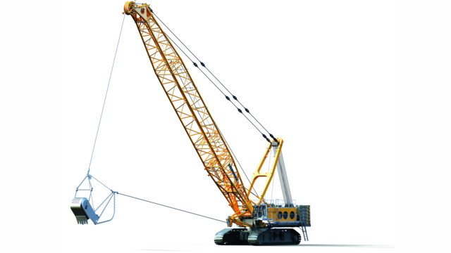

HS 8300
Electric version HS 8300 E
- ABB three–phase a.c. Motor –
2 x 345Kw
- Drive :Electric
- Liebherr Hybrid System -Pactronic®
- Consumption 240-320kWh
- Bucket Size up to 11m³
Characteristics Liebherr 8300.2 E

Dragline selection and Influencing Parameter

Overburden (OB) removal constitutes the most resource-intensive component of open-cast mining, often accounting for 60–70% of the total production cost. Its efficiency directly influences mine productivity, economic viability, and environmental performance. Open-cast mining accounts for >96% of India’s coal output and virtually 100% of rock phosphate, limestone, and bauxite. Consequently, the choice of OB removal method and equipment is central to mine planning.
The stripping ratio (SR)—expressed as bank cubic metres of OB per tonne of ore/coal—is the critical design parameter governing system selection. Indicative SR ranges for major Indian commodities are:

- Coal: 1.5–4.5 bcm/t, depending on seam thickness and depth.
- Rock phosphate: 0.5–2.0 bcm/t, reflecting shallow deposits.
- Limestone: typically <1.0 bcm/t, due to thin cover.
- Bauxite: <0.5 bcm/t, with lateritic caps of 1–5 m thickness.
- Gypsum and clays: generally <0.3 bcm/t.

These values underscore that dragline deployment is most justified in deep, bedded coal seams, whereas shallow soft-rock sectors favour smaller, flexible units

Selection of Overburden removal Equipment

Selection of an OB handling system requires a multidisciplinary assessment encompassing geological, geometric, operational, economic, and environmental factors. Comparative guidelines for typical systems are presented in the table below
Parameters | Dozer- Front-end loader | Dozer-scraper | Dragline | Excavator - truck | Excavator- mobile crusher-conveyor | Wheel excavator - conveyor
Maximum production | medium | medium | high | high | high | high
Production rate | medium | low | high | medium | medium | high
Mine life | short | short | long | medium | long | long
Mine depth | medium | flat and shallow | medium | deep | deep | medium
Deposit | Unconsolidated | Unconsolidated | Consolidated | Consolidated | Consolidated | uniform, no large boulders
Preparation | ripping | ripping | drill and blast | drill and blast | drill and blast | drill and blast
System complexity | low | medium | low | medium | high | high
Operational flexibility | high | medium | low | high | medium | low
Blending capability | high | high | low | high | medium | medium
Selective placement | good | excellent | poor | good | medium | good
Wet weather impact | high | high | low | medium | low | low
Scheduling requirements | high | low | high | high | medium | medium
System availability | medium | medium | high | medium | high | medium
Support equipment | low | medium | medium | high | high | high
Ease of start-up | simple | simple | moderate | simple | complex | complex
Investment | low | low | medium | medium | medium | high

Source - Bagherpour, Raheb. Technical and Economical Optimization of Surface Mining Processes
The matrix highlights the low unit cost but low flexibility of draglines, the scalability of shovel–truck fleets, and the selectivity of surface miners and scrapers in thin-cover deposits.
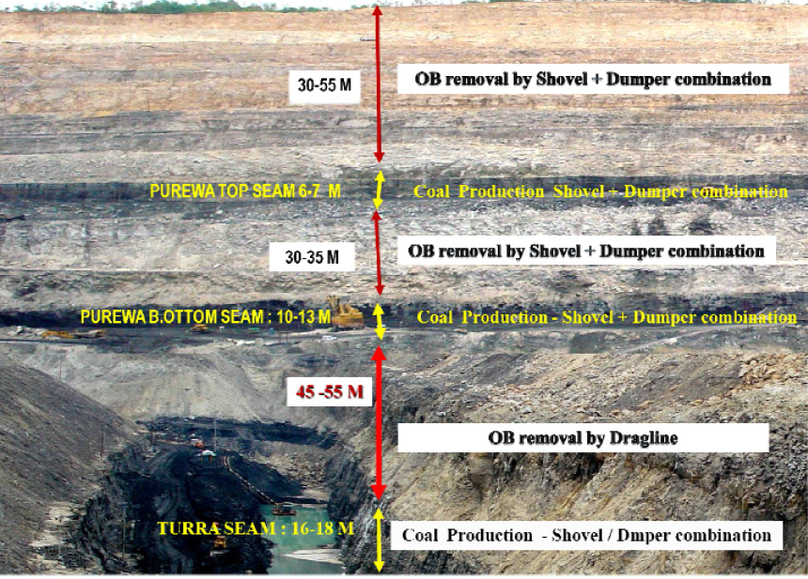

Figure 1 – A typical cross sectional view of the mine NCL

Equipment choice depends on stripping ratio, bench geometry, material hardness, production scale and environmental constraints. Progressive backfilling and reclamation are mandated in mine‑closure plans

Dragline Selection Criteria

Draglines represent one of the most significant technological investments in Indian opencast mining. Their adoption since the 1970s has transformed overburden removal in large coalfields, particularly in Northern Coalfields Limited (NCL) and South Eastern Coalfields Limited (SECL). The decision to deploy draglines is not arbitrary; it depends on a suite of geological, geotechnical, geometrical, and economic criteria, supported by appropriate infrastructure and regulatory clearances.

Mine Geometry Criteria

- Bench height: optimal 15–20 m for dragline benches. Where overburden exceeds effective digging depth, tandem draglines or shovel–dragline combinations are required.
- Cut width: must be adequate for dragline swing, coal shovel placement, and rehandle minimisation. Wider cuts are required in horizontal tandem operation.
- Pit depth: draglines remain effective for OB thickness up to 50–60 m; beyond this depth, multi-bench or hybrid systems are necessary.
- Strike length: longer strike lengths improve productivity by reducing machine relocations.
- Stripping ratio (SR): economic dragline operation is Economical up to 1:6 bcm/t; higher SR excessive rehandle.

Geotechnical Criteria

- Excavation Categories-
Draglines best suited to Cat II–III strata, Cat IV bands → require presplit or buffer blasting, Cat V → beyond dragline scope; use shovel–truck

Category | UCS (kg/cm²) | Typical material | Blasting
I | up to 55 | Alluvium, weathered OB | Nil
II | 55–125 | Soft shale/mudstone | Light
III | 125–250 | Sandstone/coal | Normal
IV | 250–1250 | Quartzite, compact sandstone | Heavy
V | >1250 | Dolerite, very hard bands | Not suitable

Table 3-2. Dragline excavation categories (after Rathi & SME Handbook)
- Swell factor (SF):
Overburden Conditions | Swell | Bucket Fill Factor
Light Blasting | 0.81 | 0.85–0.90
Medium Blasting | 0.75 | 0.80–0.90
Heavy Blasting | 0.71 | 0.75–0.85
Bad Fragmentation | 0.69 | 0.70–0.75

Source: Swell and bucket fill factors for walking draglines Adapted from Atkinson1992.
- Floor stability:
-Draglines require strong, compacted floor.( DGMS compliance (FoS ≥ 2))
-Weak clays/alluvium → may need compaction, dozer support.
- Highwall stability:
-Maintain clean, dressed highwall.
-Avoid ledges; monitor with survey and blasting control.

Importance of Fragmentation

Dragline productivity is strongly influenced by the diggability of blasted material. Poorly fragmented rock increases: Bucket fill time, Cycle time, Rope and GET wear, Rehandle %,Risk of floor and highwall damage.
Blast Fragmentation Formula (Kuznetsov–Cunningham Model)
The empirical equation for estimating average blast fragment size is:
Xm = A * (K)^(-0.8) * (115 / Sanfo)^(0.8) * Q^(1/6)
Where:
- Xm = average fragment size (cm)
- A = rock factor (dimensionless, depends on rock properties)
- K = powder factor (kg of explosives per m³ of rock)
- Sanfo = relative weight strength of explosive compared to ANFO (dimensionless)
- Q = charge quantity (kg)

Fragment Size (cm) | Increase in Dragline Performance (%)
200 | 5%
180 | 10%
160 | 15%
140 | 20%
120 | 25%
100 | 30%

Source -Economic Evaluation of Drilling and Blasting on the Dragline Dig-ability By THOMAS PHINEAS NTIMBA

- Drilling in Dragline Operations
Drilling is the foundation of dragline bench preparation. Large-diameter rotary drills (250–310 mm) with proper burden, spacing, stemming, and sub-grade control are essential for ensuring optimal blast fragmentation. Accurate drilling plans aligned to the designed highwall and void direction minimise rehandle and support safe, high-productivity dragline operation. Continuous monitoring of hole alignment, deviation, and bit performance further improves consistency.

- Blasting in Dragline Operations
Blasting in dragline operations follows the general principles of open-pit blasting, but with a crucial difference: draglines do not penetrate the muckpile like shovels; they drag their bucket across the blasted material. This makes the quality of fragmentation more critical than in shovel–truck operations. Poor fragmentation leads to oversized boulders, uneven muckpiles, reduced bucket fill factors, and longer cycle times. As Morey (1990) noted, dragline efficiency decreases much faster than shovel efficiency under sub-optimal blasting conditions.
Two blasting approaches are used in dragline operations:
- Standard (Stand-Up) Blasting – Fragmentation with little displacement. Best for stable benches and simple side casting. Produces a stable muckpile and controlled highwalls, but offers limited reduction in rehandling.
- Throw (Cast) Blasting – Fragmentation combined with 30–60% throw of overburden into the void. Best for deep, wide pits with limited dragline reach. Reduces rehandle and cycle time, boosting productivity, though it requires precise design and carries a higher risk of flyrock.

Other Criteria

Beyond geometry, geotechnics, drilling, and blasting, the deployment of draglines in opencast mines is influenced by a wider range of economic, operational, infrastructural, environmental, and regulatory factors. Rathi (2000) and subsequent DGMS/CMPDI guidelines identify the following:

Economic and Financial Factors
High capex; economical only in long-life projects; break-even SR must be favourable; full life-cycle cost must be considered

Degree of Mechanisation and Workforce Capability
Needs high mechanisation; skilled manpower; disciplined maintenance and operational culture.

Infrastructure and Support Systems
Reliable 33 kV power, haul roads, water supply, drainage/sumps, workshops, and township facilities.
- Operational Planning Factors
Mine capacity balancing; scheduling (annual/monsoon); dump design; rehandling control; auxiliary HEMM support.

Environmental Factors
Progressive backfilling; dust/emission reduction; vibration/noise control; water management; afforestation

Regulatory and Safety Factors
compliance with DGMS/CMR 2017 for benches, haul roads, dumps, highwalls; MoEFCC clearance for closure and reclamation; controlled blasting practices.

Climatic and Seasonal Factors
Monsoon rainfall and extreme temperatures impact productivity; planning required for sump drainage and safe operation.

Social and Community Factors
Land acquisition and rehabilitation; CSR and resettlement obligations; stakeholder engagement due to reduced employment in highly mechanised mines.

Operating Dimensions, Digging Approaches, and Spoil Management in Dragline Mining

The performance and applicability of a dragline in surface mining is governed not only by its rated bucket capacity and boom length, but also by a set of well-defined operating dimensions. These parameters describe the machine’s spatial working envelope and determine safe positioning, achievable digging depth, and spoil placement geometry.

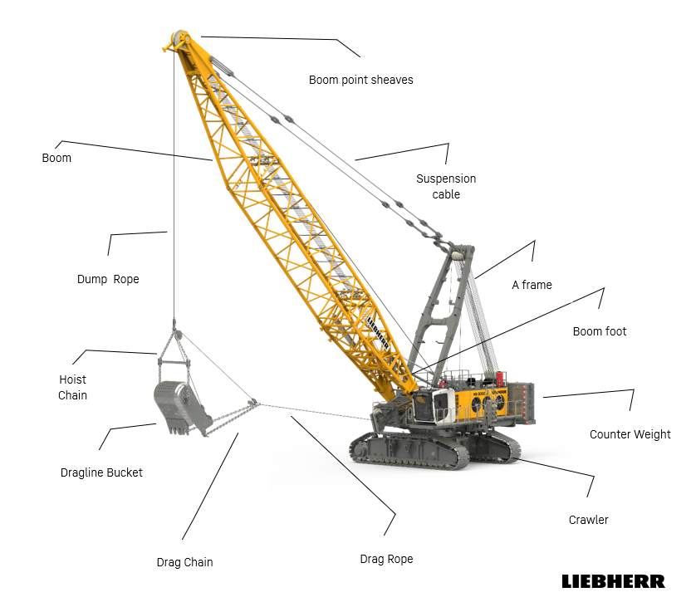
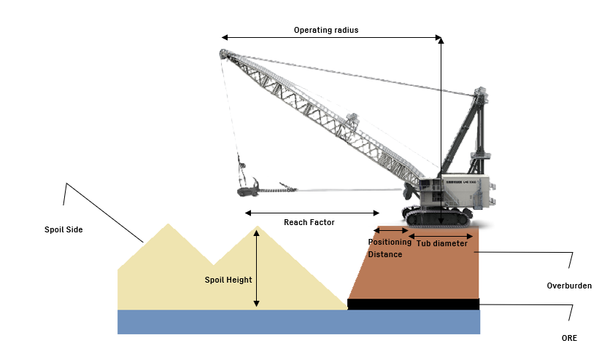

Figure 1. Main components of a dragline and Operating Perameter

Operating parameter

- Tub Diameter : The diameter of the circular base, or tub, of the dragline. This is directly relevant to ground bearing pressure and dragline positioning geometry.
- Boom Angle : The maximum inclination of the boom above the horizontal. It affects both maximum dumping height and achievable digging depth.
- Boom Foot Height : The vertical distance from the boom foot to the operating surface of the dragline.
- Dragline Positioning Distance : The offset from the dragline’s tub centre point to the edge of the operating bench. Standard practice places the machine approximately 75% of its tub diameter back from the bench crest
- Clearance Radius : The minimum radial distance that must be kept free around the dragline’s positioning centre to ensure unobstructed and safe rotation of the boom during operation.
- Boom Foot Radius : The radius of the boom foot, which forms the structural base from which the boom projects.
- Clearance Height : The minimum vertical height required above the machine to allow safe swing or rotation of the boom without interference.
- Dumping Clearance : The distance between the bucket’s highest dumping position and the boom point end. It influences safe dumping and avoidance of bucket–boom collisions.
- Dumping Height : The vertical distance from the highest point of the dragline bucket during dumping to the operating surface level of the machine. It determines the maximum spoil pile height achievable without auxiliary rehandling.
- Boom Point Height : The vertical distance from the boom point end (where hoist ropes are suspended) down to the dragline operating level, a key determinant of digging depth and spoil placement.
- Digging Depth : The maximum vertical distance the bucket can reach below the dragline’s operating level. This defines the effective cut depth that the dragline can excavate in a single pass.
- Point Sheave Pitch Diameter : The diameter of the sheave (pulley block) that carries the main hoist rope for the dragline bucket. This dimension influences rope stresses and hoisting efficiency.
- Operating Radius: The maximum radial distance from the dragline’s positioning point within which the bucket can be effectively swung for both digging and spoil casting operations. It defines the limit of the dragline’s reach into the bench and across to the spoil pile.
- Reach Factor : The maximum horizontal distance from the bench edge to the furthest point in the spoil where the bucket can be dumped. It is a key indicator of whether a dragline can directly cast material across the highwall to the spoil side without intermediate rehandling.

Classification

Draglines can be systematically classified based on their mode of propulsion and mobility. The standard classification divides them into two broad groups: self-propelled draglines and those propelled by an external agent

Classification of draglines

Cycle of Operation

                - Bucket Positioning (Empty) - The operator moves the empty bucket to the digging location in the cut. The bucket is lowered and set in position, ready to bite into the ground.
                - Dragging and Filling - The drag rope is pulled, dragging the bucket toward the machine through the cut. As it moves, the bucket scoops and fills with material.
                - Hoisting and Swinging - Once filled, the bucket is lifted (hoisted) and swung sideways toward the spoil pile. Both motions (hoist + swing) usually occur at the same time.
Two limiting conditions can occur:
Hoist critical: Hoisting takes longer than swinging → boom must wait for bucket to reach dump height.
Swing critical: Swinging takes longer than hoisting → bucket is ready but still waiting to reach dumping position.
Productivity depends on balancing these motions so neither dominates cycle time.
                - Dumping At the spoil pile - the bucket door opens (or the bucket tips) to release material. Placement must be controlled to create a stable spoil slope.
                - Returning to Digging Position - The empty bucket is swung back toward the pit while being lowered. The operator simultaneously repositions it into the next digging spot.

- Walking Patterns in Dragline Operations
Layover (Layering Over) - Dragline waits at the end of the panel until the coal is mined. Then it turns around and starts the next panel in the opposite direction. Simple, but loses production time if coal removal is delayed.
Deadheading Dragline walks (without digging) - to the start of the next cut.
Two choices:
Walk partway → start cutting in the opposite direction.
Walk to the far end → start in the same direction as before.

- Spoil Patterns - How material is dumped creates different spoil shapes:
- Short digouts, near 90° casting → straight, uniform spoil ridge.
- Long digouts → uneven peaks instead of a smooth line.
- Mixed casting angles → ragged spoil surface but balances pile height.
Other methods:
- Radial casting → dump bucket “on the fly” while swinging → cross-bedded spoil.
- Circular casting → spreads spoil widely, reduces grading costs if enough space.

Digging Modes

Underhand

A normal or underhand digging mode consists of removing the key cut, main cut and Extended Bench.
Key cut :- The key cut is a narrow trench about one and a half bucket width at the bottom. While excavating the key cut, the dragline sits on a line over the middle of the key cut in order to establish a clean and safe new highwall. Key cutting is usually the most difficult part to excavate due to the poorer fragmentation and lack of a third free face.

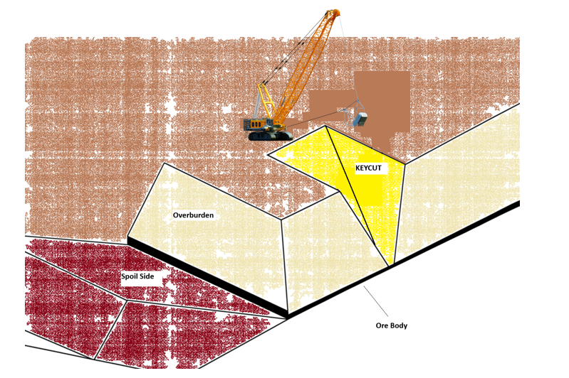
Figure 2.1- key cut in a normal underhand mode

CASTING :- The dragline is moved to the outer edge of the blasted overburden block and the remaining material is cast to the waste side.
The main reasons for this apparent time consuming action is that:
• The dragline can use its maximum reach distance; it stops the waste pushing up against the coal seam with the accompanied losses and reduces the necessity for re-handling
• Gives better visibility to the operator
• It allows for a steeper loading face to be maintained and the bucket is filled quicker and the cycle time is reduced
• The wear on the drag rope is reduced with the development of the excavation path
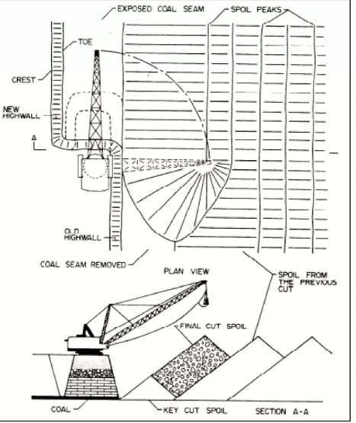
once the key cut is taken the dragline repositioning to maximize reach and minimize swing angles. The dragline moves back after casting is completed to lengthen the key cut and the cycle starts again. While dumping is taking place

Overhand

The overhand chop cutting mode is another dragline digging mode that refers to the dragline excavating material from a bench above its working bench.

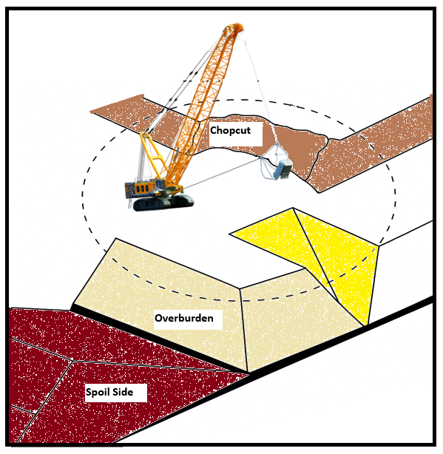
Figure 2.2- Dragline removing an advance bench in an overhand chopping mode.

- This mode of operation is frequently met in soft or undulating ground surfaces.
- In this situation, the bucket is usually held in a dump position and the teeth are dropped into the material to give the bucket penetrating force. To complete the digging procedure and filling of the bucket, the bucket is dragged downwards and towards the dragline
- The overhand chop cutting provides a stable and even working bench for the dragline in unconsolidated or rolling areas
-It also increases the maximum digging depth of the dragline (Bucyrus-Erie Co, 1977).

Disadvantages:-
- Decreases the total productivity of the dragline because the machine is working in a less efficient mode.
-The productivity losses result from longer bucket filling times, lower fill factor, longer swing angle (usually between 130 to 150 degrees) as well as increasing the dragline movements compared with normal conditions.

Spoil side & Pull back

Pull back from the spoil side is a common method in multi-pass operations or where the dragline does not have enough room to spoil all the material from a normal bridge.
- The dragline pad in the spoil side is built at a higher level than a normal bridge and closer to the spoil area .
- The technique is often used as an alternative to extended benching, particularly when the size of the dragline is insufficient to permit spoiling the material in the existing spoil room from a highwall bench.
-The dragline works in a less efficient mode than the normal mode of operation (underhand digging).

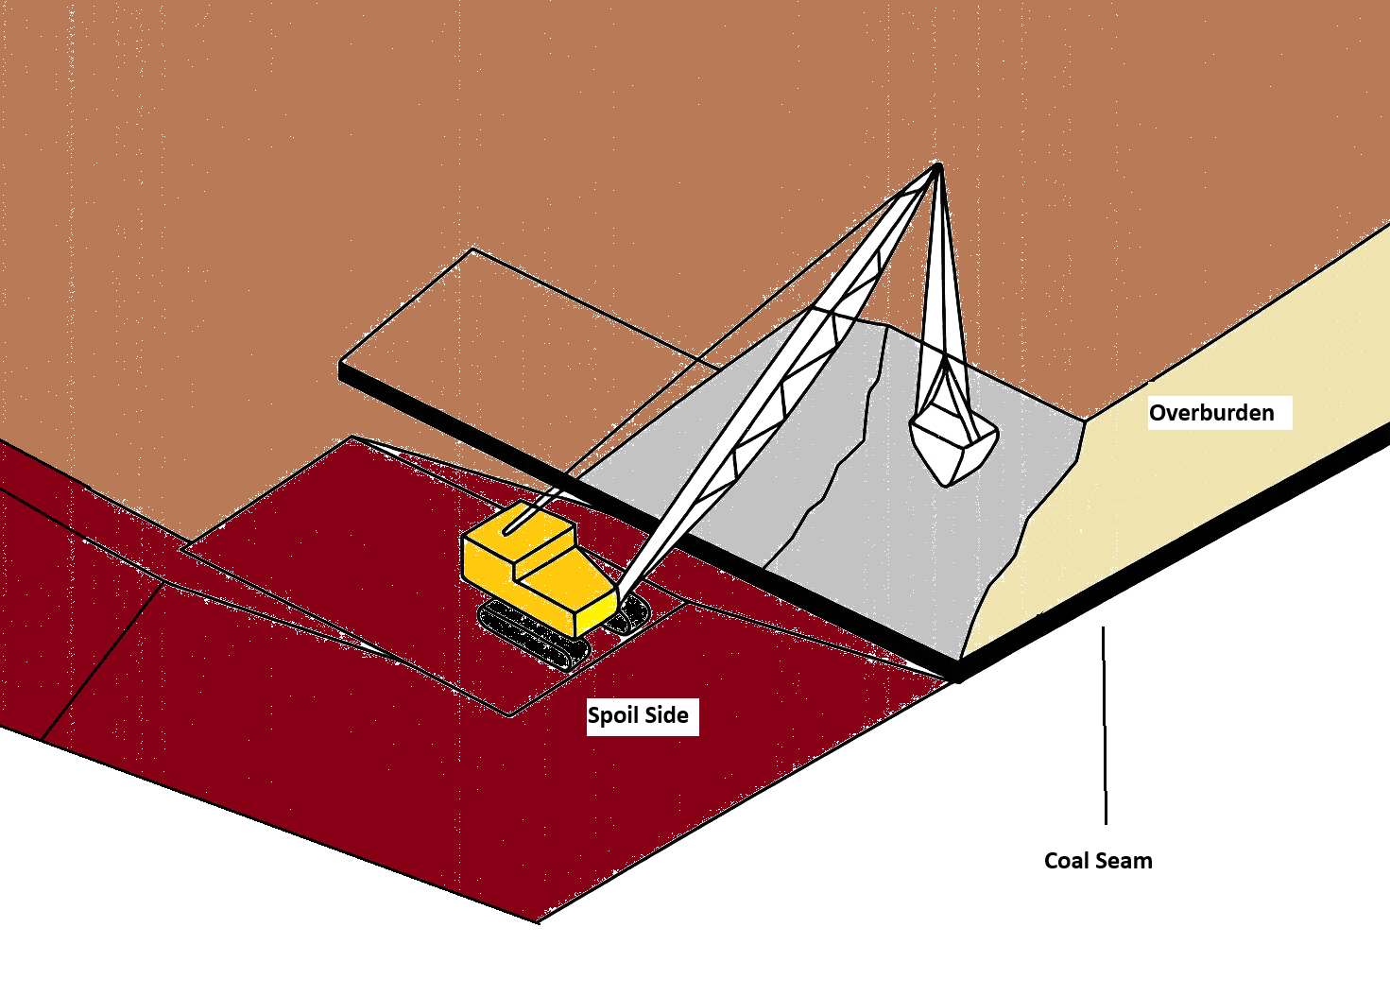
Figure 2.3- Dragline pulling back material by chopping against the highwall from a spoil side pad.
Disadvantages
- Increased dragline walking times,
- Inherent hazards of unstable spoil piles,
- Complexities of the planning and sequencing of the mining operations due to the number of different situations specially in multi-seam operations
- Additional dozing operations to prepare the dragline pad on the spoil side and the building of an additional ramp and bridge.
Spoil side stripping can result in lower productivity due to the longer swing angles and bucket fill times because of the "chopping" action of the bucket against the highwall

Stripping Casting

The main Stripping methods used are:
1. Simple side casting
2. Advance benching
3. Standard extended bench with an advance bench
4. Split bench
5. Extended key cut

Simple Side casting

Dragline placed on the main pass level surface and digging the surface of ore/coal and dropping the removed overburden in to a pile at one side. No rehandle is involved, except some rehandling around coal access ramps.
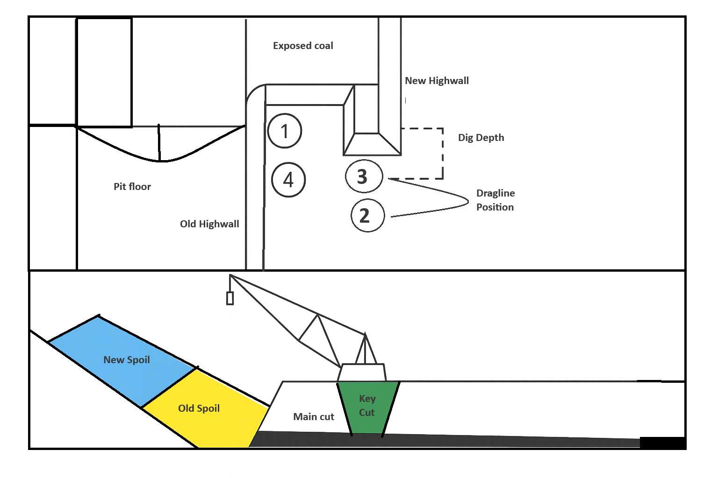
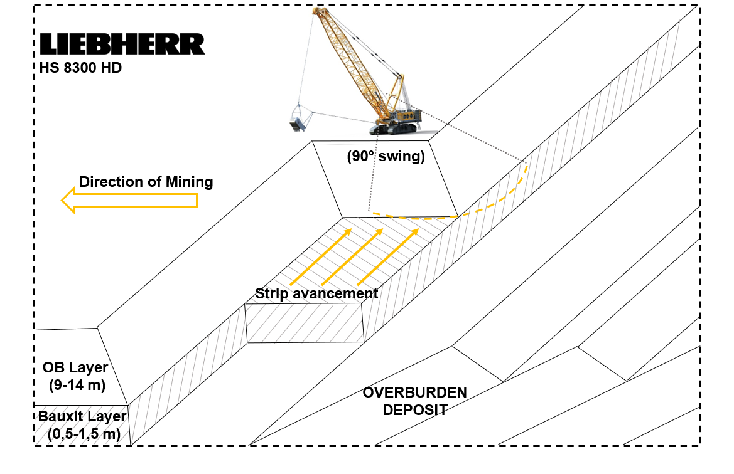
Figure -Simple side casting

Main points
- The swing angles of dragline are minimum, Applicable for shallow depth ( Shallow depth is not only the depth of the overburden, it is a relative variable which is also related to the size of the dragline used. For example, if a dragline can excavate all of the depth of overburden by Simple Side Casting, then the overburden depth can be called "shallow")
-The main disadvantage of this method is, capacity is limited and controlled by dragline geometry.

Advance Bench

It is modified of Simple casting ,When the overburden depth increases, very often, the Simple Side Casting method can be modified to an Advance Bench method to avoid rehandling.
-In this method, the level of the dragline working bench is kept lower than the original surface by forming the advance bench
Main points
- The main disadvantage of the Advance Bench is that the dragline must work in an overhand chop mode of operation
- Swing angles are greater (130 to 180 degrees) when removing an advance bench, thus reducing the dragline productivity
- There is a limitation for the height of an advance bench that a dragline can handle.
As the overburden depth increases and because of the disadvantages of chop operations, many strip mines prefer to use alternative digging methods

Extended Bench

Extended bench is used for deeper deposit, As Overburden height increases it becomes hard to dump all the overburden using the usual side casting method. This often leads to moving the same material more than once, which wastes time and money ( Rehandling % is high )

To solve this, the dragline’s reach needs to be increased. one way to do this is by placing the dragline closer to the spoil pile. This gives more space to dump the material and makes it easier to place all the overburden into the previous pit.
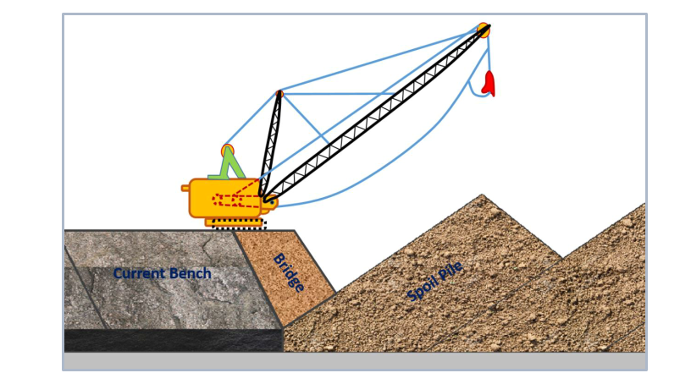
Figure 6 Extended bench (modified from Bucyrus-Erie Company Handbook,2001)
Main points
- To improve the dragline’s performance, an extended bench or bridge is often built. This bridge lets the dragline move closer to the spoil pile, helping it reach the top of the spoil more easily.
The material used to make the extended bridge is provided from both the keycut and the advance bench
-Used material is rehandling material and must be excavated later to clear the coal edge of next block
The critical factors that affect the amount of rehandle are the dragline spoiling capabilities, material swell factor, highwall angle and spoil angle.
Combine approach with this method :- It is also possible to combine the standard Extended Bench method with a throw blasting operation.

Purpose of the Method
- Increase dragline reach without modifying the machine.
- Improve spoil placement by allowing dumping at the spoil crest.
- Reduce rehandling and improve operational efficiency.
- Integrate blasting and excavation for better productivity.

Split Bench

In order to increase the maximum advance bench depth and to avoid a chop down operation, two underhand dragline passes are used in each strip.

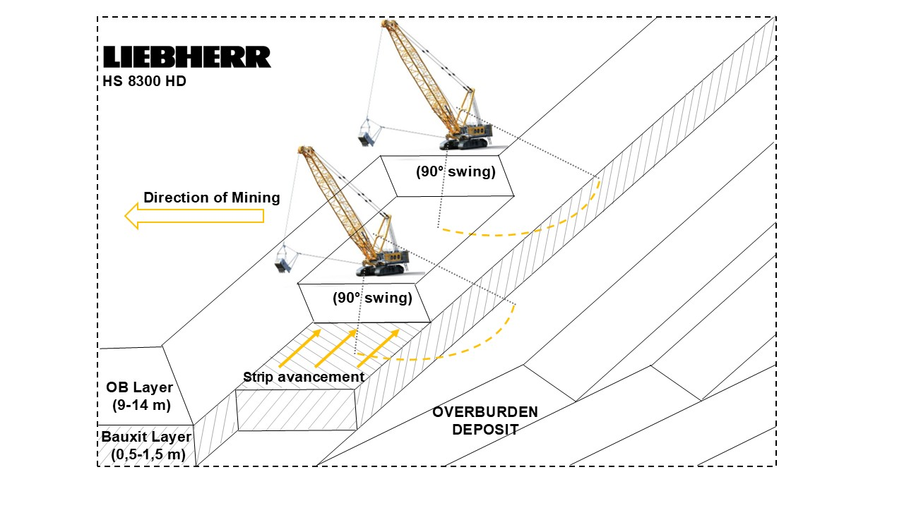

Figure 7. Split bench
bench on the lowwall side on blasted material,
-The main dig level is controlled by the maximum dig depth of the dragline and the spoil balance.
-The method involves two highwall passes using simple side casting in the first pass and a conventional extended bench in the main pass.

Extended Key cut

Two-pass operation method is extended key cut method which employing a highwall extended cut in first cut and low wall pullback operation in the second pass:
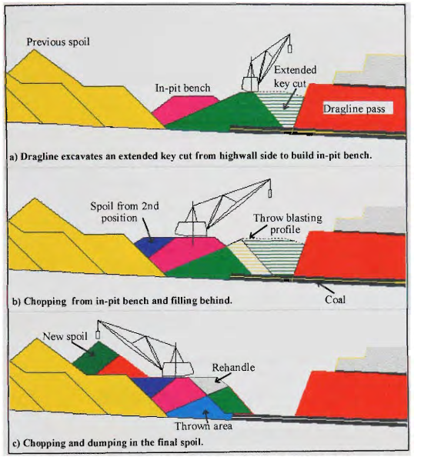
Extended Key cut

a) Dragline excavates an extended key cut from highwall side to build in-pit bench: The dragline is shown on the right (highwall) side, digging the "Extended key cut" and using that material to build the "In-pit bench" on the left.
b) Chopping from in-pit bench and filling behind: The dragline has moved onto the in-pit bench. It is now removing the remaining overburden (the "Throw blasting profile") and depositing it behind itself as "Spoil from 2nd position."
c) Chopping and dumping in the final spoil: This shows the continuation of the second pass. The dragline continues to chop down and dump the overburden, creating the "New spoil" pile. The area where the blasted material initially landed is the "Thrown area," and any material that needs to be moved again is referred to as "Rehandle."

Blasting and Fragmentation

Digging methods that rely on the dragline sitting on a stable highwall crest and performing simple, direct excavation. Blasting in dragline operations is similar to regular open-pit blasting. However, unlike shovels that push into the broken rock, draglines work by dragging their bucket across the blasted material. This means the quality of fragmentation is more important for draglines. If the rock isn't broken well, the dragline's efficiency drops much faster than a shovel working in the same conditions. As a result, good blasting is more critical for dragline operations than for shovel operations. (Morey, 1990)
Fragment size distribution: Targeted at <800 mm to ensure efficient dragline bucket filling.
There are two primary blasting philosophies:
- Standard Blasting (Stand-Up Blasting)
- Throw Blasting (Cast Blasting)

Rehandling

In large opencast mines, draglines are predominantly employed for overburden (OB) stripping. The overall efficiency of a dragline operation is closely tied to the minimization of rehandling, i.e., the repeated movement of the same material. Rehandling not only consumes productive cycles without adding value but also inflates energy, wear, and cost metrics, thereby increasing the Total Cost of Ownership (TCO) of the equipment.

Balancing Diagram

To evaluate spoil balance, mine planners make use of the dragline balancing diagram—a geometric cross-sectional tool that represents the relative dimensions of the excavation cut, spoil void, and coal seam. This diagram provides both visual and quantitative insight into whether the volume of overburden (in bank cubic metres, BCM) removed from the active cut can be fully accommodated in the available spoil void, after accounting for swell factor and dragline dumping reach. By doing so, it links geological parameters (bench height, cut width, dip, slope) with operational parameters (bucket capacity, swing angle, spoil angle of repose, rehandle percentage).

Component of Diagram

A₁ (Excavation area): Cross-sectional area of overburden to be stripped, multiplied by swell factor to convert in-situ volume into loose cubic metres.
A₂ (Spoil area): Geometrically available void for dumping, constrained by dragline dump radius, spoil slope, and highwall geometry.
A₃ (Balance factor): A3=A1×S−A2

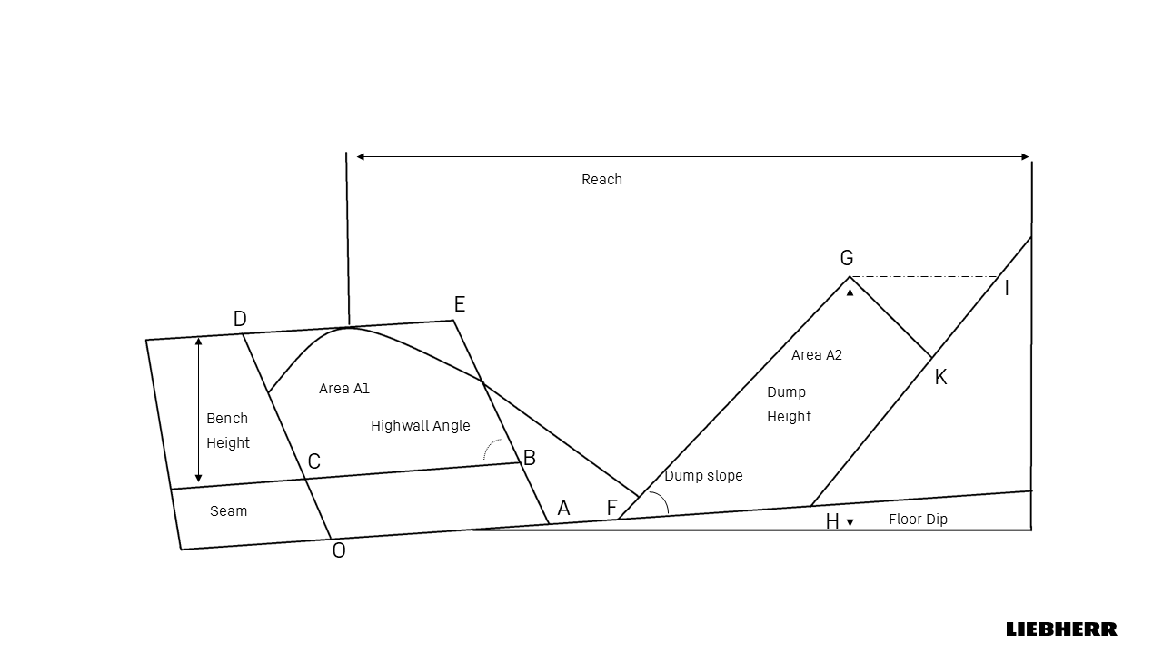
Dragline Balancing Diagram

Area A1 = BCDE = Bench width x Bench Height
Area A2= FHKG = FHIG-GKI
A3=A1×S−A2

where S is the swell factor.
  - A₃ < 0: Surplus spoil capacity; cut width/bench height can be optimized upward.
  - A₃ = 0: Balanced condition; no rehandling.
  - A₃ > 0: Excess OB beyond spoil void; rehandling required.

Functions of the Balancing Diagram

According to Indian and international research:
- Coal exposure estimation: Calculates how quickly and efficiently coal is uncovered per cut.
- Dragline workload allocation: Balances tasks across multiple machines depending on productivity.
- Rehandling estimation: Identifies % of OB that must be handled twice.
- Bench design: Provides guidance on optimum bench height and cut width for reduced unit cost.
- Mine planning integration: Used in simulation models (CADSIM, DRGX, MINESCAPE) for strip layout and pit optimization.

Production and Influencing Factor

Draglines are among the largest and most efficient earthmoving machines employed in surface mining. In India, they dominate overburden (OB) removal in coalfields and are increasingly considered for use in non-coal deposits such as phosphates, limestone, and bauxite, where high stripping ratios and environmental constraints demand bulk excavation at low cost. Their ability to directly cast material from the highwall to the spoil side without intermediate haulage provides unmatched productivity and unit cost advantages compared to truck–shovel fleets.
Yet, actual dragline output in the field often falls short of rated potential. The primary reasons include inflated cycle times due to unfavorable geometry, poor blast fragmentation, idle hours caused by coordination delays, and reduced equipment availability. To maximize the economic advantage of draglines, it is therefore critical to model production rigorously, quantify influencing factors, and integrate these parameters into mine planning and Total Cost of Ownership (TCO) frameworks.

Production formula and Factors

Annual Production ( m3/Year)
Q= Cb × Ff × SF× ( 3600 / C ) × M × (Ns × Nh × Nd) × A × U
where:
- Cb= rated bucket capacity (m³)
- Ff = bucket fill factor SF = swell factor (loose/bank)
- C = average cycle time (s)
- M = travel/position factor
- A= Mechanical Availability U= Utilization
- Ns = shifts/day, Nh = hours/shift, Nd = operating days/year.

Production Factor Influence

  - Bucket Capacity- The Volume of bucket is direct proportional to total production

Rathi, P.D. Opencast Mine Planning, Deployment of HEMM for Optimum Utilisation, Total Technical Parameters of HEMM Including Limitations, and Haul Road & its Maintenance.

  - Fill Factor and Swell factor – Dragline Productivity dependent on material behavior. Two parameters are particularly critical in this regard: the swell factor (SF) and the fill factor (Ff). These parameters act as multipliers in the dragline production equation and together determine the conversion between theoretical and realized output in terms of bank cubic meters.

    - Influence of Rock Type - The swell factor is defined as the ratio between the volume of fragmented rock in a loose state and its original in-situ bank volume, while the fill factor expresses the proportion of the rated bucket capacity actually filled during operation. Both vary significantly with Lithologe.
Rock | Swell | Swell factor | Fill Factor
Asbestos ore | 1,4 | 0,71 | 0,85
Basalt | 1,6 | 0,62 | 0,8
Bauxite | 1,35 | 0,74 | 0,9
Chalk | 1,35 | 0,76 | 0,9
Clay (dry) | 1,25 | 0,8 | 0,85
Clay (light) | 1,35 | 0,76 | 0,85
Clay (heavy) | 1,35 | 0,74 | 0,8
Clay and gravel (dry) | 1,3 | 0,76 | 0,85
Clay and gravel (wet) | 1,35 | 0,74 | 0,8
Coal (anthracite) | 1,35 | 0,74 | 0,9
Coal (bituminous) | 1,35 | 0,74 | 0,9
Coal (lignite) | 1,3 | 0,76 | 0,9
Copper ore (low-grade) | 1,5 | 0,66 | 0,85
Copper ores (high-grade) | 1,6 | 0,62 | 0,8
Earth (dry) | 1,3 | 0,76 | 0,95
Earth (wet) | 1,3 | 0,76 | 0,9
Granite | 1,55 | 0,64 | 0,8
Gravel (dry) | 1,25 | 0,8 | 1
Gravel (wet) | 1,35 | 0,74 | 1
Gypsum | 1,5 | 0,66 | 0,85
Limenite | 1,4 | 0,71 | 0,85
Iron ore 40% Fe | 1,4 | 0,71 | 0,8
Iron ore – 40% Fe | 1,45 | 0,68 | 0,8
Iron ore – 60% Fe | 1,55 | 0,64 | 0,75
Iron ore (taconite) | 1,65 | 0,6 | 0,75
Limestone (hard) | 1,6 | 0,62 | 0,8
Limestone (soft) | 1,5 | 0,66 | 0,85
Manganese ore | 1,45 | 0,68 | 0,85
Phosphate rock | 1,5 | 0,66 | 0,55
Sand (dry) | 1,5 | 0,86 | 1
Sand (wet) | 1,15 | 0,86 | 1
Sand and Gravel (dry) | 1,15 | 0,86 | 1
Sandstone (porous) | 1,6 | 0,62 | 0,8
Sandstone (cemented) | 1,6 | 0,62 | 0,8
Shales | 1,45 | 0,68 | 0,8

Some properties for various materials which are important for loading machine evaluation.
Atkinson (1971), Atkinson (1992).

    - Interaction with Bucket Capacity- The relationship between bucket size, swell factor, and fill factor is illustrated in Figure, where two rock conditions were modelled: one representing harder overburden (50% Category III + 50% Category IV) and another representing softer conditions (90% Category III + 10% Category IV).
Two insights are evident. First, the fill factor increases with bucket capacity.. Second, the swell factor remains relatively constant across capacities, confirming that muck looseness is primarily dictated by geology and blasting, not by bucket size. Thus, while capacity upgrades improve filling efficiency, they cannot compensate for adverse swell conditions.

Rathi, P.D. Opencast Mine Planning, Deployment of HEMM for Optimum Utilisation, Total Technical Parameters of HEMM Including Limitations, and Haul Road & its Maintenance.

    - Effect of Blasting Practices- While the geological nature of the overburden defines the baseline behaviour of swell and fill, blasting practice exerts a decisive influence on both parameters. Controlled blasting studies and operational records from Indian coalfields demonstrate that the intensity and quality of blasting significantly modify the looseness of the muck pile and the ease of bucket filling.

Overburden Conditions | Swell Factor | Bucket Fill Factor
Light Blasting | 0.81 | 0.85–0.90
Medium Blasting | 0.75 | 0.80–0.90
Heavy Blasting | 0.71 | 0.75–0.85
Bad Fragmentation | 0.69 | 0.70–0.75

Atkinson (1971), Atkinson (1992).

  - Cycle Time - cycle time (C), defined as the average time required to complete one full digging and dumping sequence
dragline cycle can be decomposed into four distinct phases:
- Placement and Digging (Tpd): The bucket is lowered, positioned, and dragged through the muck pile until filled.
- Swing to Spoil (Ts): The bucket is hoisted and swung towards the spoil area, often performed concurrently with hoisting.
- Dumping (Td): The bucket is tipped or the dump door opened to release material at the spoil crest.
- Return Swing and Lowering (Tr): The empty bucket is swung back and lowered into the digging position.
Thus, the total cycle time is expressed as:
C= Tpd +Ts +Td + TrC

- Theoretical Cycle Times - Theoretical cycle times for draglines of varying bucket capacities under different swing angles. It is evident that as swing angle increases, cycle time rises almost proportionally, regardless of bucket size.

 | Theortical cyle time
Bucket size | Swing Angle
(m³) | 90° | 120° | 150° | 180°
up to 15 | 55 | 62 | 69 | 77
16–26 | 56 | 63 | 70 | 78
27–44 | 57 | 64 | 71 | 79
45–57 | 59 | 65 | 72 | 80
58–92 | 60 | 66 | 73 | 81
93–150 | 62 | 69 | 76 | 84

Theoretical Cycle Time According to Dragline Operation Swing Angles and Bucket Size
(Source: Karpuz and Hindistan (2005) in Eskikaya et al. (2005))

    - Mechanical Availability and Utilization –

Availability (A) refers to the proportion of scheduled time during which the machine is in a mechanically operable state, regardless of whether it is actually producing. It accounts for losses caused by both planned and unplanned downtime.
A = [ SSH – (MH + BH) ] / SSH

An availability of 0.85, for example, indicates that 85% of the scheduled time the machine was ready to operate, while the remaining 15% was lost to maintenance and breakdowns

Utilization (U) extends this concept by measuring the fraction of scheduled hours during which the dragline is not only available but also productively working. In addition to downtime, it subtracts idle delays when the machine is operational but cannot be used due to mine-side constraints. no blasted muck available,
- delays in floor preparation,
- power interruptions,
- shift-change activities,
- cable handling and relocation.
Thus, utilization is always lower than availability, since it accounts for both machine-related and external constraints.
U = [ SSH – (MH + BH + IH) ] / SSH
SSH = scheduled shift hours,
MH = maintenance hours,
BH = breakdown hours,
IH = idle hours (e.g., no blasted muck, floor prep, power, shift change, cable handling).

The multiplication of A and U is Operating efficiency
 | Utilization
Availability | Excellent | Good | Fair | Poor
Excellent | 0.84 | 0.81 | 0.76 | 0.7
Good | 0.78 | 0.76 | 0.71 | 0.64
Fair | 0.72 | 0.69 | 0.65 | 0.6
Poor | 0.63 | 0.61 | 0.57 | 0.52

Dragline Operating Efficiency , Source Humphrey 1990
This is example for SCCL Mines
Mine Equipment | Scheduled shift hours (SSH) | Working hours (WH) | Maintenance hours (MH) | Breakdown hours (BH) | Idle hours (IH) | Availability factor (A) | Utilization factor (U)
15/90 | 720 | 501 | 161 | 32 | 26 | 0.7319 | 0.6958
24/96 | 720 | 619 | 59 | 25 | 17 | 0.8833 | 0.8597
24/96 | 744 | 594 | 49 | 68 | 33 | 0.8427 | 0.7983
24/96 | 720 | 507 | 119 | 33 | 61 | 0.7888 | 0.7041
30/92 | 744 | 408 | 137 | 30 | 161 | 0.7755 | 0.5483

    - Travel/position factor ( M)

Draglines are largely stationary over multiple cycles and only relocate after completing a panel or key cut. However, two categories of losses are always present:

Travel losses: Downtime incurred during dragline walking between adjacent panels, extended benches, or repositioning within the cut. Although infrequent, each walk may take 30–60 minutes, reducing effective working time.
Mt=1− Walking hours/ Scheduled operating hours
​
Spotting/positioning losses: Small but frequent time penalties when the bucket is not ideally positioned at the toe during digging, or overshoots the spoil crest during dumping. Spotting corrections extend cycle time and reduce fill efficiency.

Mp​=1− Spotting correction time​ / Cycle time

M=Mt​×Mp​

Other Factor

- Stripping Method and layout
- Panel Width and Digout length and Bench height
- Operating perameter

Fig. 6—Influence of collar oversize on the digging time for different capacity draglines

Production Example For Coal mine -
ANNUAL PRODUCTIVITY OF WALKING DRAGLINES AND VARIABLES FOR ITS CALCULATION
EXCAVATION | (50% Cat III + 50% Cat IV)
 |  |  | Bucket cycle time  IN Min |  | PRODUCTIVITY OF  DRAGLINE Million M3
Bucket Capacity (m³) | Swell Factor | Bucket Fill Factor | 90° Swing | 120° Swing | 90° Swing | 120° Swing
4 | 0,719 | 0,867 | 1,227 | 1,353 | 0,51 | 0,463
5 | 0,719 | 0,871 | 1,227 | 1,353 | 0,641 | 0,581
6,1 | 0,719 | 0,874 | 1,227 | 1,353 | 0,784 | 0,711
6,9 | 0,719 | 0,877 | 1,227 | 1,353 | 0,89 | 0,807
8,4 | 0,719 | 0,883 | 1,227 | 1,353 | 1,091 | 0,989
10 | 0,719 | 0,888 | 1,227 | 1,353 | 1,306 | 1,184
11,5 | 0,719 | 0,894 | 1,227 | 1,353 | 1,512 | 1,371
12 | 0,719 | 0,896 | 1,227 | 1,353 | 1,581 | 1,434
14 | 0,719 | 0,903 | 1,227 | 1,353 | 1,859 | 1,686
15 | 0,719 | 0,906 | 1,227 | 1,353 | 1,999 | 1,813
16 | 0,719 | 0,91 | 1,227 | 1,353 | 2,141 | 1,942
20 | 0,719 | 0,924 | 1,227 | 1,353 | 2,718 | 2,465
24 | 0,719 | 0,938 | 1,227 | 1,353 | 3,311 | 3,003
26 | 0,719 | 0,946 | 1,227 | 1,353 | 3,618 | 3,218
27 | 0,719 | 0,949 | 1,227 | 1,353 | 3,769 | 3,418
29,8 | 0,719 | 0,959 | 1,227 | 1,353 | 4,203 | 3,812
31 | 0,719 | 0,963 | 1,227 | 1,353 | 4,391 | 3,982
32 | 0,719 | 0,967 | 1,227 | 1,353 | 4,551 | 4,127
Rathi, P.D. Opencast Mine Planning, Deployment of HEMM for Optimum Utilization, Total Technical Parameters of HEMM Including Limitations, and Haul Road & its Maintenance.

ANNUAL PRODUCTIVITY OF WALKING DRAGLINES AND VARIABLES FOR ITS CALCULATION
(90% Cat III + 10% Cat IV)
 |  |  | Bucket cycle time  In Min |  | PRODUCTIVITY OF  DRAGLINE Million M3
Bucket Capacity (m³) | Swell Factor | Bucket Fill Factor | 90° Swing | 120° Swing | 90° Swing | 120° Swing
4 | 0,732 | 0,88 | 1,176 | 1,303 | 0,55 | 0,496
5 | 0,732 | 0,884 | 1,176 | 1,303 | 0,691 | 0,623
6,1 | 0,732 | 0,887 | 1,176 | 1,303 | 0,845 | 0,763
6,9 | 0,732 | 0,89 | 1,176 | 1,303 | 0,959 | 0,866
8,4 | 0,732 | 0,896 | 1,176 | 1,303 | 1,176 | 1,061
10 | 0,732 | 0,901 | 1,176 | 1,303 | 1,408 | 1,27
11,5 | 0,732 | 0,907 | 1,176 | 1,303 | 1,68 | 1,471
12 | 0,732 | 0,909 | 1,176 | 1,303 | 1,704 | 1,538
14 | 0,732 | 0,916 | 1,176 | 1,303 | 2,003 | 1,808
15 | 0,732 | 0,919 | 1,176 | 1,303 | 2,154 | 1,944
16 | 0,732 | 0,923 | 1,176 | 1,303 | 2,307 | 2,082
20 | 0,732 | 0,937 | 1,176 | 1,303 | 2,928 | 2,642
24 | 0,732 | 0,951 | 1,176 | 1,303 | 3,566 | 3,218
26 | 0,732 | 0,959 | 1,176 | 1,303 | 3,895 | 3,516
27 | 0,732 | 0,962 | 1,176 | 1,303 | 4,058 | 3,662
29,8 | 0,732 | 0,972 | 1,176 | 1,303 | 4,525 | 4,084
31 | 0,732 | 0,976 | 1,176 | 1,303 | 4,727 | 4,266
32 | 0,732 | 0,98 | 1,176 | 1,303 | 4,899 | 4,422
Rathi, P.D. Opencast Mine Planning, Deployment of HEMM for Optimum Utilization, Total Technical Parameters of HEMM Including Limitations, and Haul Road & its Maintenance.

Cost Modal - Total Cost of Ownership

The deployment of draglines in surface mining, particularly in coalfields and large non-coal deposits, requires not only a technical assessment of productivity but also a rigorous evaluation of economic viability as its very huge investment.

The Total Cost of Ownership (TCO) framework provides a holistic basis for such evaluations. Unlike simple capital cost comparisons, TCO captures the complete life-cycle cost of the dragline, from acquisition and erection through operation, maintenance, rebuilds, and eventual retirement.
For mining applications, TCO is typically expressed as a unit cost (₹/bank m³ or ₹/t of coal exposed). This normalisation enables fair benchmarking between draglines and competing systems such as shovel–truck fleets or bucket wheel excavators under equivalent geological and operational conditions.

The TCO structure comprises four interrelated elements:
- Ownership costs – fixed, time-based charges including CAPEX, depreciation, average investment, and IIT (Interest, Insurance, and Taxes).
- Operating costs – variable, utilisation-dependent charges such as labour, energy, consumables, ropes, preventive maintenance, and rebuilds.
- Unit cost metrics – normalised cost per bank m³ or tonne, allowing benchmarking across systems.
- Discounted Average Cost (DAC) – NPV-based comparator for long-term projects.

Ownership cost

Ownership costs reflect the financial burden of procuring and retaining the dragline in service, irrespective of its utilization. They are calculated annually and apportioned per m3 of overburden.

        - Capital Expenditure (CAPEX)
CAPEX comprises the upfront investment required to procure, transport, assemble, and commission the dragline. For a HS 8300-class machine, CAPEX typically ranges between ₹600–900 crore in Indian conditions.

Disaggregated Components of CAPEX-Purchase Price (OEM) Shipping & Transport, Erection & Assembly, Civil Works & Infrastructure, Commissioning & Testing
In India, dragline procurement involves long lead times (3–5 years from tender to commissioning), meaning CAPEX planning must integrate financing, exchange rate risk, and government approval cycles.

        - Depreciation (D)
Depreciation allocates the CAPEX over the economic life of the dragline (20–30 years). Different methods alter cost profiles:

Method | Formula | Key Mining Application | Notes
Straight-Line (Fixed Depreciation) | D = (Cp - S) / n | Used in Coal India Ltd. (CIL), CMPDI feasibility studies. | Cp = Purchase cost of the machine (CAPEX)  S = Salvage value  n = Useful service life (years)  D = Annual depreciation  Dt = Depreciation charge in year t  BV(t-1) = Book value of the machine at the beginning of year t  r = Depreciation rate  Qtot = Total expected lifetime output  Qyear = Actual annual output in that year  t = Year number
Written Down Value (WDV) | Dt = BV(t-1) × r | Applied for taxation in Indian mines under Income Tax Act.
Units-of-Production | D = (Cp - S) / Q tot × Q year | Used in international dragline models (Australia, USA).
Sum-of-the-Years’-Digits (SYD) | Dt = (n - t + 1) / [n(n+1)/2] × (Cp - S) | Occasionally used in feasibility modelling for mines.
Double Declining Balance (DDB) | Dt = 2 × (1/n) × BV(t-1) | Rare in mining feasibility but seen in global mining finance.

n = Useful service life (years) for dragline is range between 15-28 Years

For dragline Straight-Line (Fixed Depreciation)

(d) Annual Interest, Insurance, and Taxes (IIT)
Annual Investment and Interest on Investment: Instead of calculating interest on the initial purchase price, the concept of Annual (Average) Investment (AAI) is used. This reflects the mean book value of the machine over its economic life.
AAI = (n+1) / (2n) × Cp
Here:
Cp = Purchase cost of the machine (CAPEX)
n = Useful life in years ( 18-25 years)
Interest Insurance and Taxes (IIT): Interest, Insurance, and Taxes (IIT) is a consolidated cost block included in the ownership cost of high-CAPEX mining equipment such as draglines.
IIT=rIIT​×AAI
Where: - IIT = Annual Interest, Insurance & Taxes (₹)
- r_IIT = Combined flat rate (typically 10–15%)
- AAI = Annual Average Investment = (n+1)/(2n) × Cp

In CMPDI practice, rIIT is applied as a bundled rate of 15% of AAI. Internationally, components are calculated separately:
- Interest: 8–12% (based on WACC or RBI lending rates).
- Insurance: 0.5–1.5%.
- Taxes: 1–2%.
Thus, annual ownership cost is:

OC=D+IIT

Operating cost
Operating costs dominate over the long life cycle of a dragline and are highly sensitive to utilisation (U), availability (A), energy consumption, and maintenance quality.

Key components include
(a) Labour (LC)
Labour cost covers operators, helpers, maintenance crews, and supervisors. For continuous three-shift operation, each dragline requires:
- 1–3 operators per shift,
- 1–3 helpers per shift,
- 0–2 electricians/fitters/welders on a rotating roster,
- Supervisory engineers and safety staff.
Formula:
LC=(Nop Wop+NhpWhp+NmtWmt+NsupWsup)×S
Where:
- Nop = Number of operators per shift
- Wop = Annual wage per operator
- Nhp = Number of helper per shift
- Whp = Annual wage per helper
- Nsup = Supervisory staff
- Wsup = Annual wage per supervisor
- Nmt = Maintenance staff
- Wmt = Annual wage per maintenance staff
- S = Number of shifts per year
(b) Energy (EC)
For electric draglines (dominant in India):
EC=P×H×Ce
Where: P = avg. power (kW), H = annual hours, Ce= tariff (₹/kWh).
For diesel-based draglines:
EC=F×H×Cf
Where F = L/h consumption, ​ Cf = ₹/L diesel.

Other cost
- Lubricants and Consumables (LCn): Oils, greases, hydraulic fluids.
- Spare Parts and Components (SP): Replacement of motors, gears, chains, etc.
- Wire Ropes and Drag Chains (WR): Major recurring expense.
- Preventive Maintenance (PM): Scheduled inspections and minor overhauls.
- Major Rebuilds (RB): Life-extension programs every 8–12 years.

(c) Lubricants & Consumables ( LCN)
Empirical regression for HS 8300 draglines shows:
Lube% of energy=548.8/EC

This indicates that as energy cost rises, the percentage share of lubrication cost falls, stabilising near 5–6%.

(d) Maintenance & Spares (SP+WR+PM)
Maintenance cost is strongly correlated with energy cost and operating hours. For HS 8300 machines:
Maintenance % of energy=285.0 * EXP(-0.012084*Energy cost+ 1.8e 05*WorkingHours)

(R² ≈ 0.97, based on operational regression data).

(e) Major Rebuilds or breakdown cost (RB)
Draglines require life-extension rebuilds every 8–12 years, costing 20–30% of CAPEX. Averaged annually, rebuilds ≈ 2% of CAPEX/year.

Thus, annual operating cost (OPC) = Labour cost+ Energy cost+
maintenance cost+ Major rebuilds
Total cost (TC)= Annual ownership cost (OC) + Annual operating cost (OPC)

Indicative cost distribution

CAPEX Component | Typical Share (%) | Notes
Purchase Price | 60–70% | Dominant, covers OEM supply of dragline
Shipping & Transport | 5–10% | Depends on distance, import duties
Erection & Assembly | 10–15% | High due to site complexity and long erection cycle
Civil Works & Infra | 5–8% | Substations, pads, roads, drainage
Commissioning & Testing | 2–3% | Trial runs, reliability checks

Component IIT | General Consideration | Typical Percentage Range
Interest | Cost of capital or opportunity cost; usually based on WACC or RBI lending rate. | 8–12 %
Insurance | Annual premium for coverage against damage, accidents, natural hazards. | 0.5–1.5 %
Taxes | Statutory levies, machinery/property tax, GST on insurance. | 1–2 %
Bundled IIT (India) | CMPDI/CIL apply a flat rate instead of separating components. | 10–15 % (combined)

Component Lube , Maintenance and Breakdown | India (CMPDI/Thesis Practice for big machinery ) 25 year | HS 8300
Lubricants & Consumables (LCn) | ≈30% of Energy cost (rule of thumb) | 3-13 % of Energy cost ( 10-18 years)
Maintenance (SP, WR, PM) | ≈20% of depreciation (bundled rule of thumb) | 61-226 % of Energy cost ( 10-18 years)
Breakdowns & Major Rebuilds (RB) | ≈2% of CAPEX/year averaged (or 20–30% per cycle every 8–12 years) | No separate Data available

Unit cost

To benchmark across mines:
- Unit Cost per m3=(OC+OPC)/Qannual
- Unit Cost per tonne=(OC+OPC)/Qannual in ton
- Unit Cost per tonne ore =(OC+OPC)/Qannual ore in ton

TCO Tool development

Draglines are capital-intensive assets in Indian surface coal mining, with acquisition and commissioning costs that can reach several hundred crore rupees. Their economic justification relies on the ability to move large volumes of overburden at the lowest unit cost (₹/m3).

Introduction and Objective

Conventional feasibility studies often evaluate draglines either on production capacity or on cost elements, without integrating both into a lifecycle decision-support framework.

The tool development was guided by four objectives:
1. To create a transparent, modular framework for dragline TCO.
2. To integrate production, cost, and ESG (energy, carbon) dimensions into a single evaluation platform.
3. To implement cost allocation at both annual and discounted NPV levels.
4. To enable direct comparison between dragline and truck–shovel systems.

The purpose of this chapter is to present the Unified Mining Analysis – Dragline TCO Tool , developed as a web-based application. The tool integrates:
- Production equations (cycle-time based, adjusted for availability and utilization),
- Ownership and operating cost accounting,
- Energy and emissions intensity, and
- Discounted cash-flow economics (NPV and payback).

This module supports direct benchmarking of draglines against truck–shovel systems, under operating and cost conditions

Technical Specifications of TCO Tool

- System Architecture
- The tool is a client-side web application (HTML5/JS/CSS) with three layers:
- Interface: input panels, dashboards, export functions.
- Computation: cycle-based production models, cost equations, regression for lube & maintenance.
- Output: KPI dashboard, cost & ESG charts, auto-generated Word reports.
- Module Workflow (8 steps)
- Equipment setup (dragline, shovel, truck, dozer).
- Material & OEE inputs (density, swell, fill, A, U, M).
- Cycle modelling (swing, haul, pass).
- Production outputs (m³/h, bcm/year).
- Cost inputs (CAPEX, OPEX, ownership, regressions).
- ESG (energy, CO₂ intensity, carbon cost).
- Economics (NPV, payback, cashflow).
- Dashboard & executive summary.
- Default Parameters
- Dragline: 10.8 m³ bucket, 54 s cycle, A = 0.88, U = 0.78, life 20.5 y, energy 70 kWh/h.
- Shovel–truck: 5.4 m³ shovel, 60 m³ truck, life 10–17 y.
- Dozer: 38.4 m³ blade, A = 0.90, U = 0.80, life 18 y.
- System Requirements
- Runs in Chrome/Firefox/Edge.
- ≥ 2 GHz dual-core CPU, 4 GB RAM, <50 MB storage.
- Innovation
- Integrates production, cost, and ESG in one tool.
- Benchmarks dragline vs truck–shovel vs dozer.
- Exports structured reports for feasibility studies.

Module work flow of Dragline

- Step 1 – Equipment Configuration: Users define system assets: draglines (bucket, cycle, method), Quantities and specifications are entered to model heterogeneous fleets.
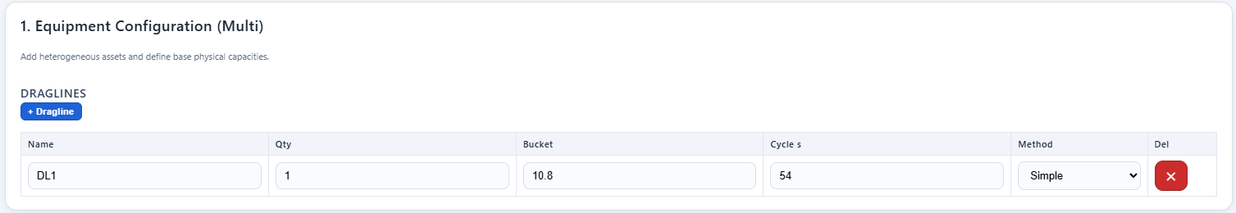

- Step 2 – Material, OEE & Calendar: Inputs include material density, swell factor, calendar hours, availability, utilization, fill factor, spotting factor, and rehandling parameters.

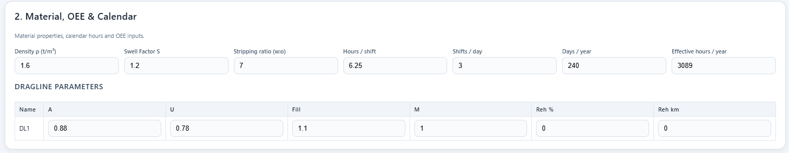

- Step 3 – N/A for dragline

- Step 4 – Production (LCM): Hourly and annual production are computed from cycle-based equations. Outputs include dragline m³/h, annual bcm, and coal tonnes exposed.
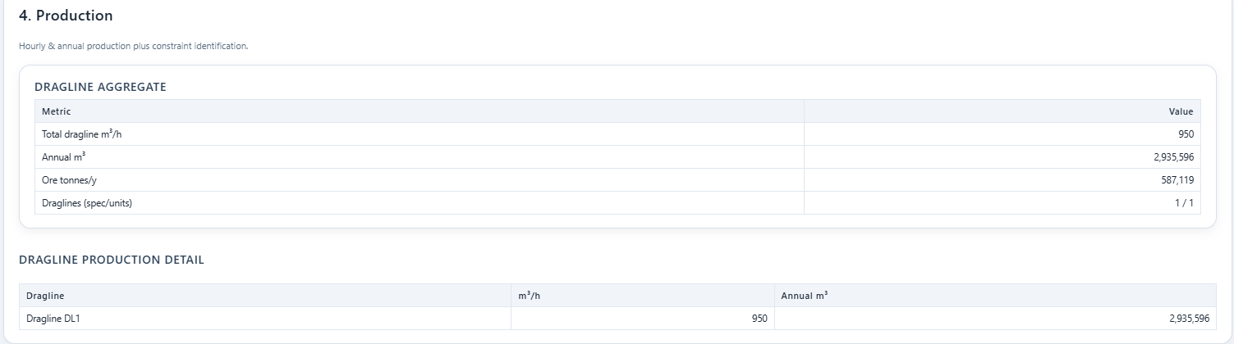

- Step 5 – Cost Inputs & Ownership: CAPEX, OPEX, salvage, operator costs, energy consumption, maintenance, and breakdown reserves are entered. Outputs: Ownership + OPEX totals.

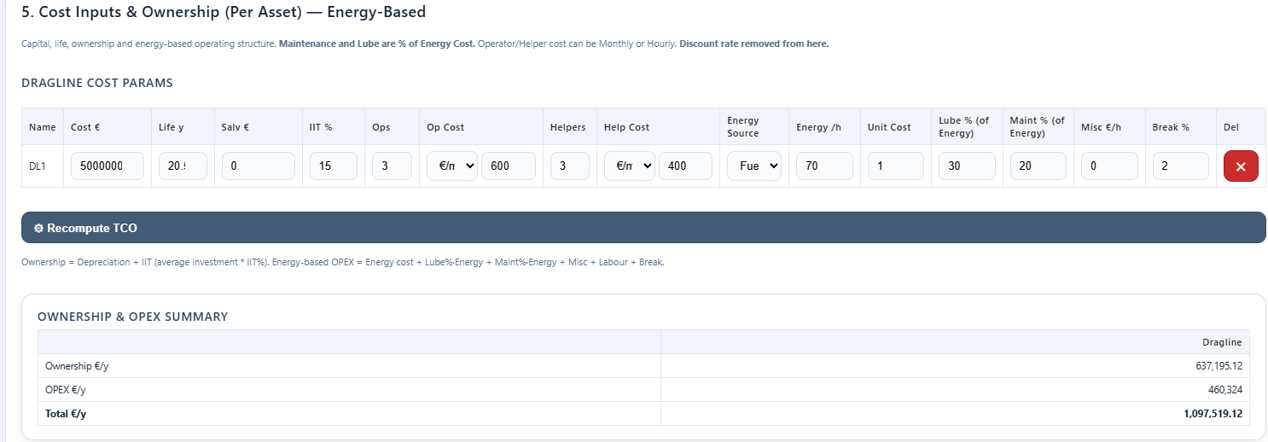

- Step 6 – ESG & Unit Economics: Environmental and energy parameters applied: carbon emission factor, carbon pricing, and fuel consumption. Outputs: production cost, carbon intensity, climate contribution.

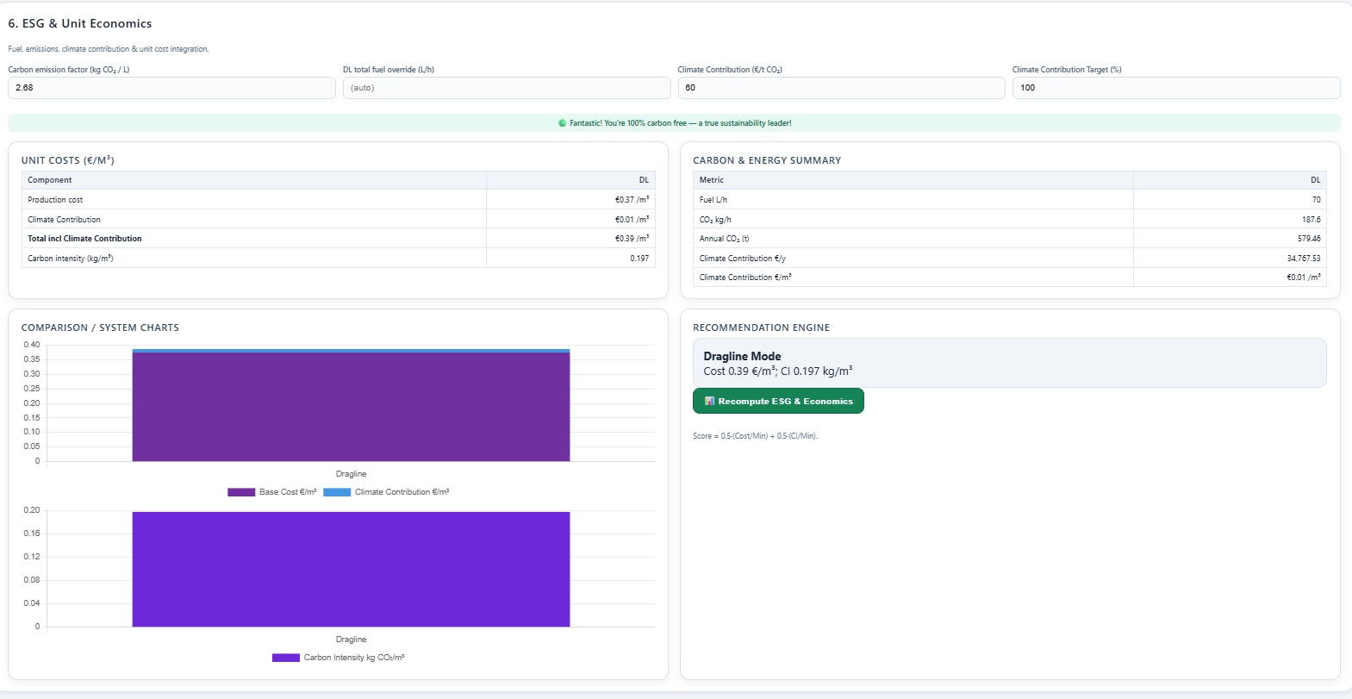

- Step 7 and Step 8– Economic Evaluation (NPV & Payback) and Executive Summary snapshot : Discounted cash-flow analysis using commodity price, discount rate, project life, salvage, and escalation. Outputs: NPV, payback period, margin. And cost €/m3, Climate contribution
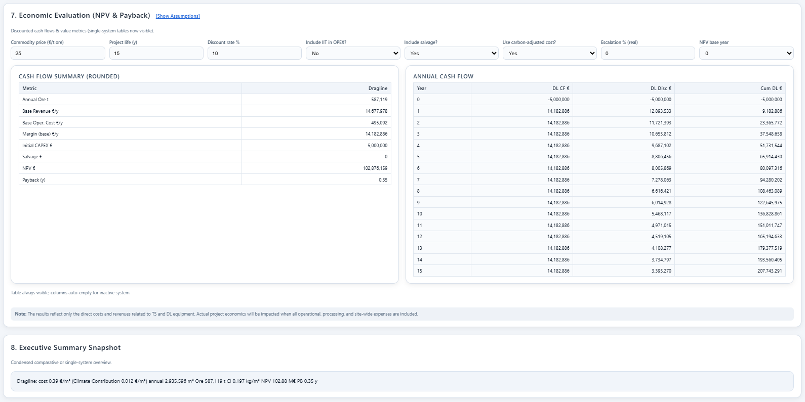

KPI Dashboard Output

The final Result of the TCO Tool provides a KPI Dashboard, which consolidates all production, cost, and ESG indicators into a single decision-support interface (Figure 6.X). Results are expressed in user-defined currencies (₹/€, USD) with real-time exchange rate scaling.

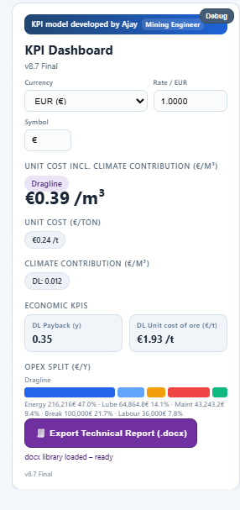
Example -
- Tco Outputs:
- Unit Cost Incl. Climate Contribution (€/m³): €0.39/m³
- Unit Cost (€/ton): €0.24/t.
- Climate Contribution (€/m³):€0.0012/m³.
- Economic KPIs:
- Payback period: 0.35 years.
- Unit cost of ore exposure: €1.93/t.
- OPEX Split:
The dashboard automatically breaks down annual operating costs into major categories:
- Energy: €216,216 (47.0%)
- Lubricants: €64,864 (14.1%)
- Maintenance: €43,243 (9.4%)
- Breakdowns/Rebuilds: €100,000 (21.7%)
- Labour: €36,000 (7.8%)
This decomposition highlights energy as the dominant cost driver, accounting for nearly half of dragline OPEX, followed by lubrication and breakdown reserves.
- Export Functionality:
The tool includes a direct export function to Microsoft Word (.docx), which generates structured reports containing:
  - Executive summary,
  - Input assumptions,
  - KPI dashboard,
  - OPEX split charts,
  - ESG indicators, and
  - Payback/NPV analysis.

Clarification on Scope

The developed tool also includes modules for Truck–Shovel systems and comparative benchmarking against draglines. However, the analytical scope of this thesis is strictly limited to dragline feasibility and TCO analysis. Truck–shovel modules and comparison results are presented within the tool for completeness, but they are not included in the detailed analysis or conclusions of this thesis

Maintenance and Case Study

Result and conclusion

List of Figures

Figure 1: Montanromantik 2

List of Tables

Table 1: Table 2

List of Abbreviations
U. S. P. | Unique selling proposition

Annex Table of Contents

Annex

